Connecting TikTok Lead Ads to MiniCRM
Step 1. Sign up for a Leadsbridge account
There is a FREE version, but it’s limited to 50 leads / month, only 1 bridge and only 2 fields that can be connected. So most times, your customers will need at least the Starter plan (https://leadsbridge.com/pricing-plans/)
Step 2. Create a bridge
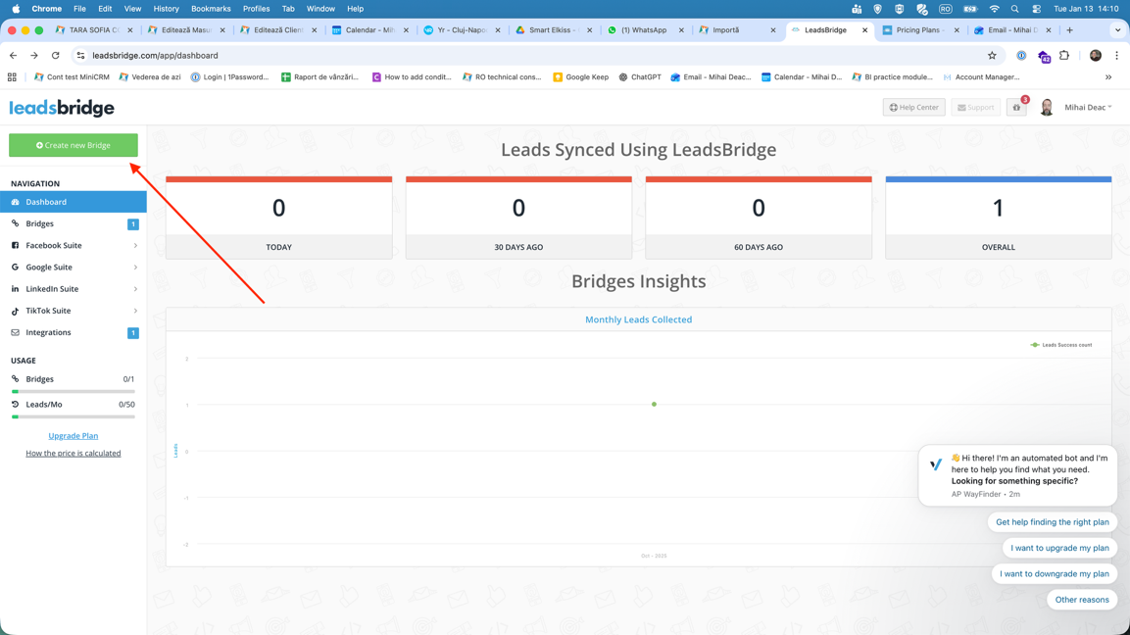
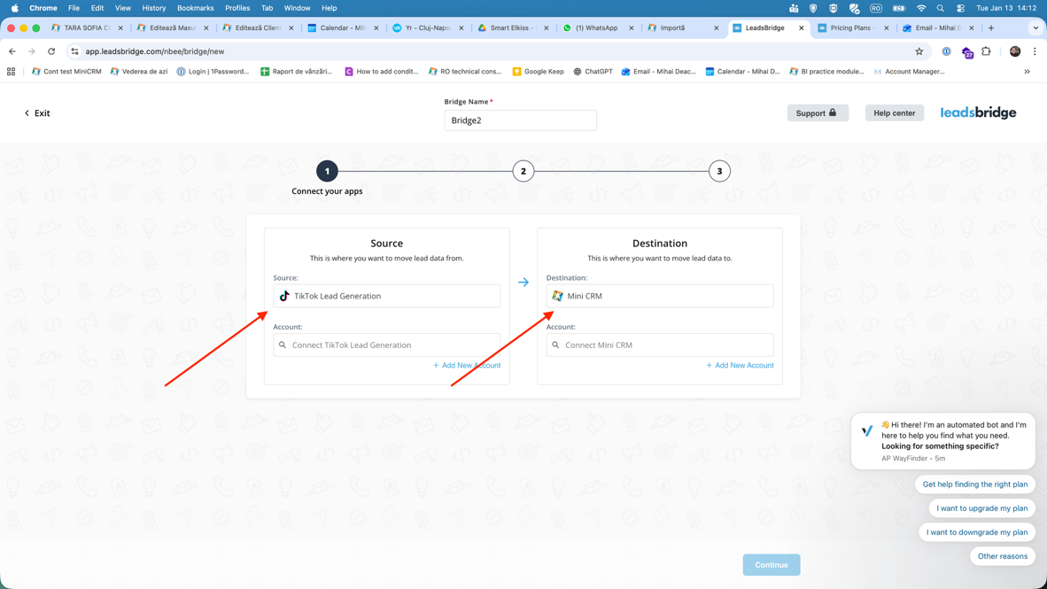
Step 2.1 Connect to a TikTok ad account and a form from that account

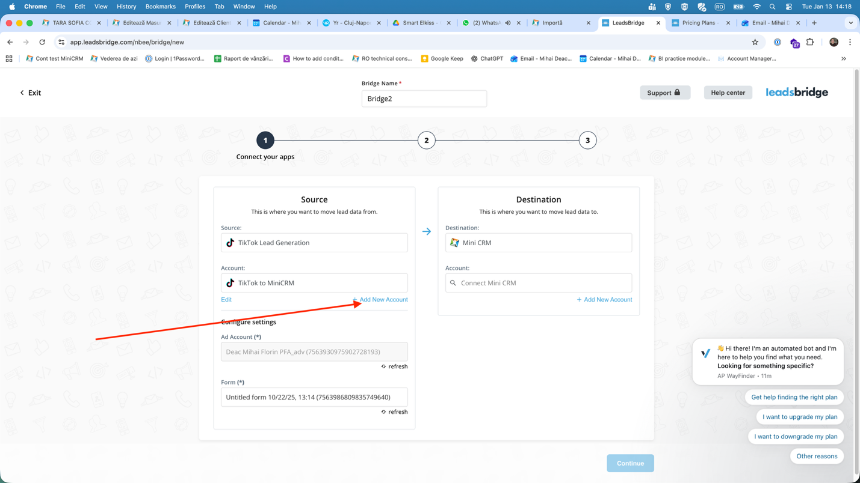
You will need to authorize it. There will be a popup for this that will prompt for your TikTok credentials.
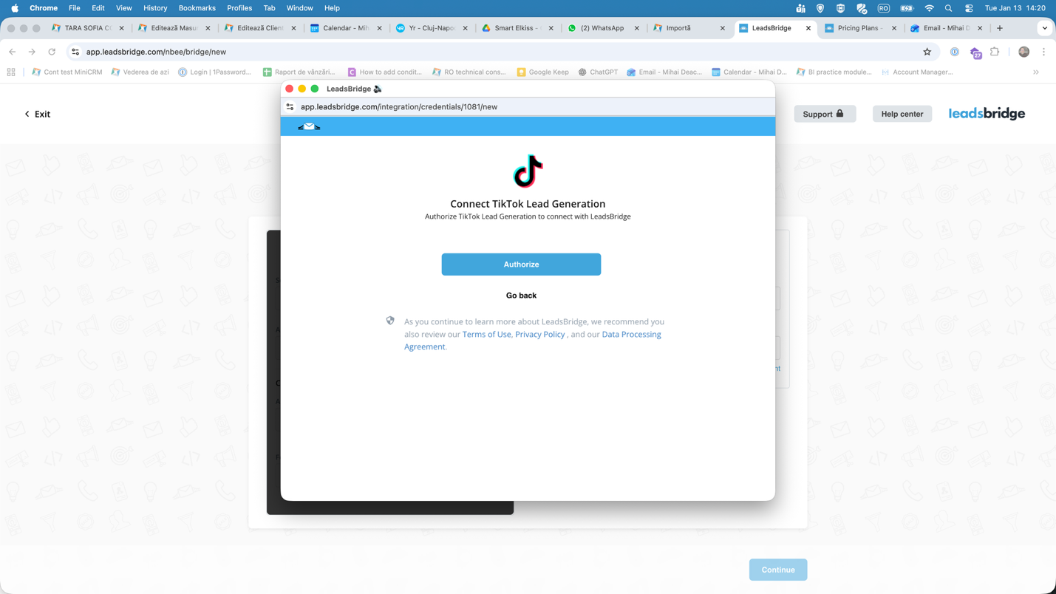
After you authorize, you will be able to select a form from that account.
Step2.2 Connect the MiniCRM form
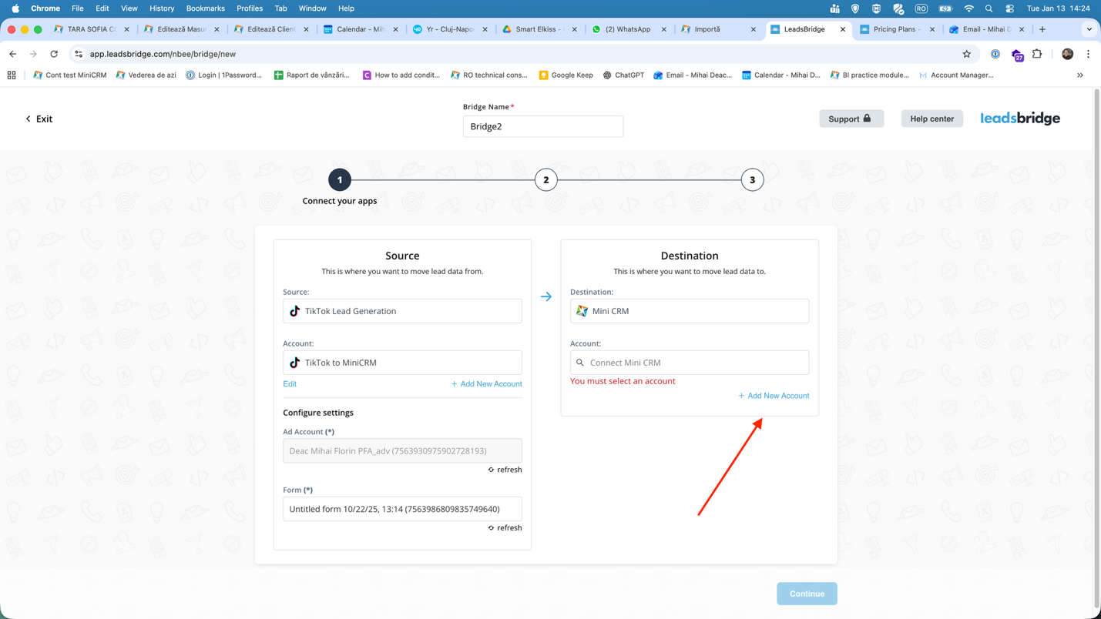
In the following screen you can insert the script of your MiniCRM form as seen below:
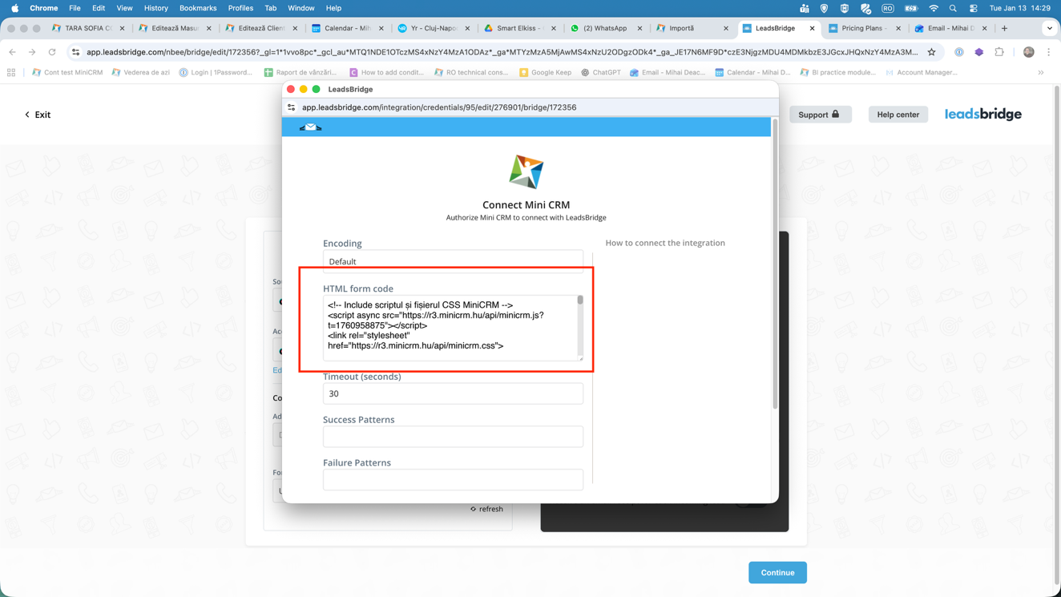
IMPORTANT NOTE: Leadsbridge seems to not see the formhash parameter, which will lead to an error. This is why, in the script, after the Formhash, you should add a line of code. See the example:
<form FormHash="62181-1sl7gr8qot0xs5pfi651023fam4xs5" action="https://r3.minicrm.hu/Api/Signup" method="post" class="TurnKeyCRM" id="Web">
<input type="hidden" name="MiniCRM_FormHash" value="62181-1sl7gr8qot0xs5pfi651023fam4xs5">
After that you can click on Authorize. You will be sent back to the bridge screen, where you can click “Continue”.
Step3. Mapping the fields
MiniCRM fields should show up authomatically. You just need to select the fields from TikTok on the left side of the screen. After you’re done, you can test the connection and you should see your first lead in MiniCRM.
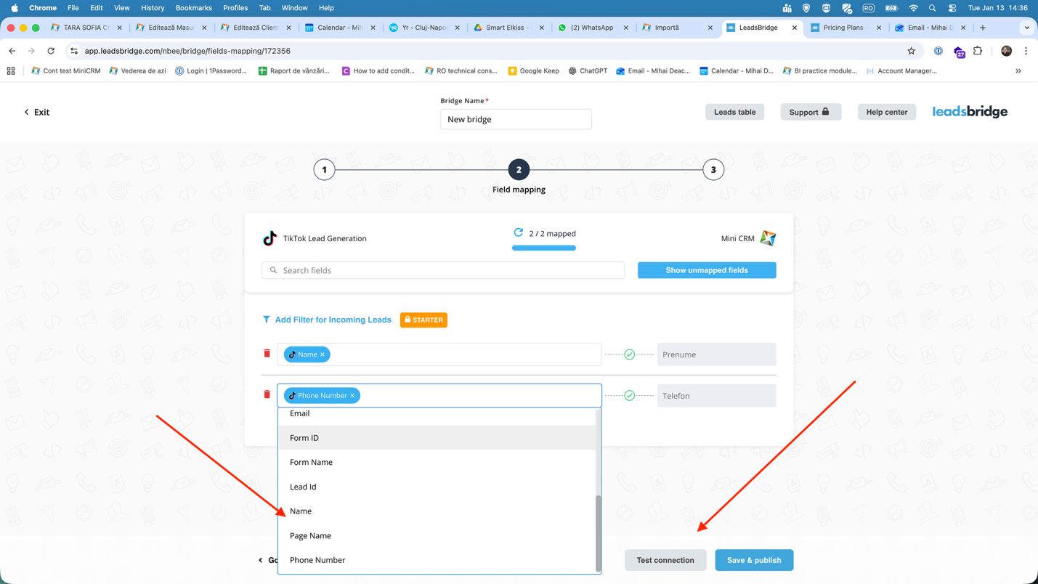
Notes: be careful with compulsory fields. If there is an email field in your MiniCRM form it is obligatory by default, so make sure to also connect an email field from TikTok.

